A

Project Report on

**<Title>**

Submitted in partial fulfillment of completion of the course

Advanced Diploma in IT, Networking and Cloud

Submitted by:

**Team Member-1**

**Team Member-2**

**Team Member-3**

**Team Member-4**

Under Guidance of:

**<IBM Mentor> (IBM/Kyndryl)**

**<IBM Mentor> (IBM/Kyndryl)**

**<Edunet Mentor> (Edunet)**

|  |  |  |
| --- | --- | --- |
| IBM-Logo - Chicago Innovation | DGT introduces high end diploma courses - digitalLEARNING Magazine | Edunet Foundation-Delhi- CSR Organization profile |

Year 2022

Abstract

Acknowledgement

Team Composition and Workload Division

Table of Contents

1. Introduction to Problem
2. Literature Review
3. Proposed Solution
4. Requirements

4.1 Technology Stack

4.2 Hardware

4.3 Software

4.4 Deployment Environment

5. User Requirements

6. Design Documentation

7. Implementation Details

8. Testing

9. Deployment

10. Future Scope

11. Conclusion

Appendix A Project Code

Appendix B Screenshot of Project

Appendix C abbreviation

References

Instructions:

1. Font- Arial
2. Main /Title Heading- 16 (bold, center aligned)
3. Heading-14 (bold)
4. Sub heading-12 (bold)
5. Normal text-12
6. Text Alignments- Justified
7. Image/Screenshot/Table Alignments- Center
8. Caption below Images/screenshot/table - Centre, Font size 8
9. References to be numbered in square box like [1] ….
10. Any code to be attached as appendix at the end like Appendix A, Appendix B …
11. Screenshots of project can also be attached as appendix

**Literature Review**

**Reviewing Literature**

**A literature review** in a thesis is a critical review of literature relevant to your field of study. It’s not a summary of the whole field, or a haphazard regurgitation of everything you’ve read in the field but an organized and critical discussion that lets your reader see what you’ve ‘made’ of the literature relevant to the topic of your thesis and your research question. It functions to contextualize your research within that research field by identifying where there are gaps in previous research that your own research will help to fill. To see how a literature review can be organized so that it provides a critical review of the field relevant to the thesis topic and shows how previous research both informs and provides a rationale for the suggested research, see the annotated discipline examples.

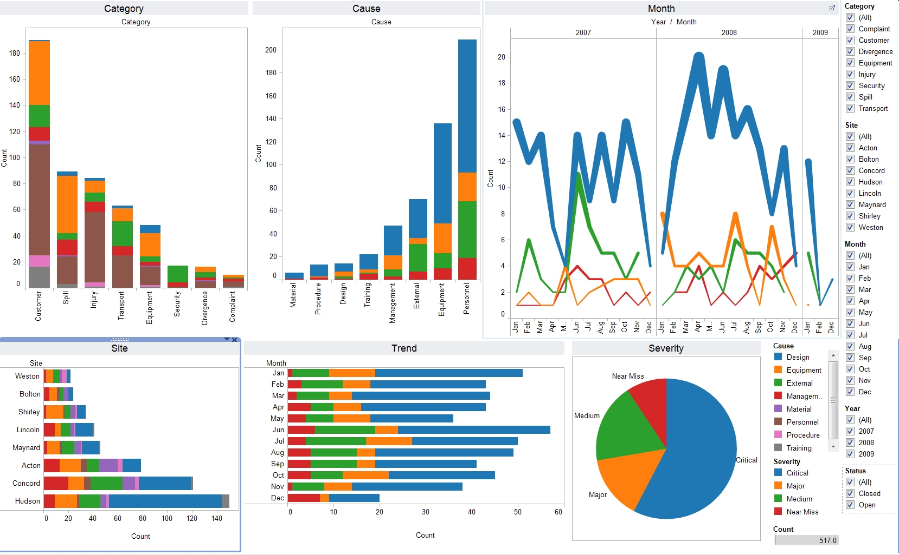

Image:1 Data visualization of electronics manufacturing market Reference: [data_visualization_python.jpg (1658×1026) (wp.com)](https://i1.wp.com/www.simplifiedpython.net/wp-content/uploads/2018/07/data_visualization_python.jpg?resize=1658%2C1026&ssl=1)

**Appendix A**

**Project Code**